**Mini Project Report on**



**WEB DEVELOPMENT USING ADVANCE TOOLS**



**Submitted in partial fulfillment of the requirement for the award of the degree of**

**BACHELOR OF TECHNOLOGY**

**IN**

**COMPUTER SCIENCE & ENGINEERING**

**Submitted by:**

**Student Name:** **University Roll No.:**

**CHAITANYA UNIYAL 2019658**

***Under the Mentorship of***

**Mr. Ramesh Singh Rawat**

**Assistant Professor**



**Department of Computer Science and Engineering**

**Graphic Era (Deemed to be University)**

**Dehradun, Uttarakhand**

**January 2023**



**CANDIDATE’S DECLARATION**

I hereby certify that the work which is being presented in the project report entitled **“Web Development Using Advance Tools”** in partial fulfillment of the requirements for the award of the Degree of Bachelor of Technology in Computer Science and Engineeringof the Graphic Era (Deemed to be University), Dehradun shall be carried out by the under the mentorship of **Mr. Ramesh Singh Rawat, Assistant Professor**, Department of Computer Science and Engineering, Graphic Era (Deemed to be University), Dehradun.

Name: Chaitanya Uniyal University Roll No.: 2019658

**Table of Contents**

|  |  |  |
| --- | --- | --- |
| **Chapter No.** | **Description** | **Page No.** |
| Chapter 1 | Introduction | **4-5** |
| Chapter 2 | Literature Survey | **6-7** |
| Chapter 3 | Methodology | **8-10** |
| Chapter 4 | Result and Discussion | **11-12** |
| Chapter 5 | Conclusion and Future Work | **13-14** |
|  | References |  |

**Chapter 1**

**Introduction**

Web development is the process of creating and maintaining websites. It involves a combination of skills such as coding, design, and user experience. In this mini project, we will be using advanced tools and technologies such as HTML, CSS, Bootstrap, PHP, and XAMPP to create a college website that is both visually appealing and functional.

* 1. **Introduction**

Welcome to our mini project on web development using advanced tools. The project aims to create a comprehensive and visually appealing website for a college, using a combination of HTML, CSS, Bootstrap, PHP, and XAMPP. The website will serve as an online platform for students, faculty, and staff to access important information and resources related to the college.

One of the key features of the website is its responsive design, which ensures that the website looks great and is easy to navigate on any device. We have used Bootstrap v5.0.2 , a popular front-end framework, to create a consistent and visually appealing layout across all pages.

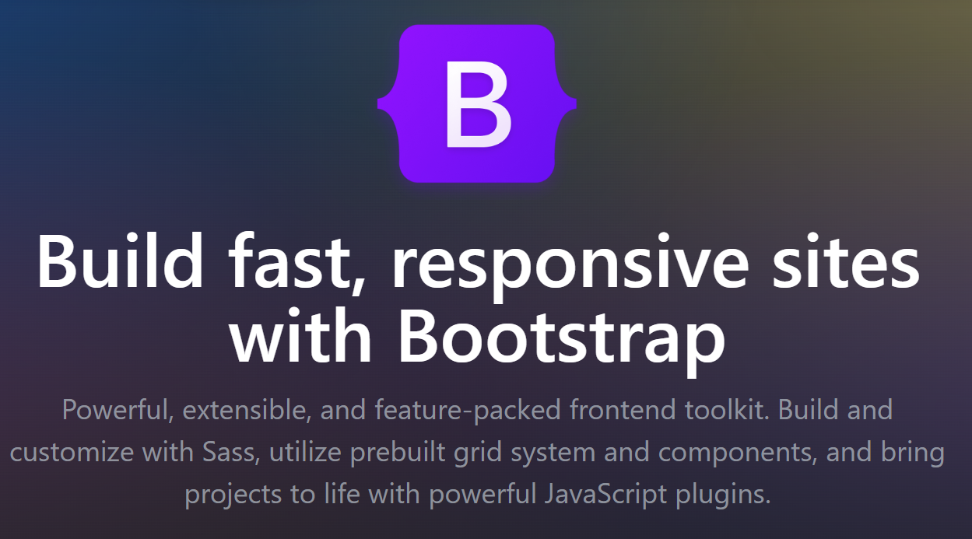

**Figure 1.1** Bootstrap

In addition to the front-end design, we have used PHP to create dynamic pages that can display content from a database. This allows for easy updating of information such as course schedules, faculty profiles, and news updates. XAMPP, a software bundle that includes Apache, MariaDB, PHP and Perl, has been used to create a local development environment to test and run the website.

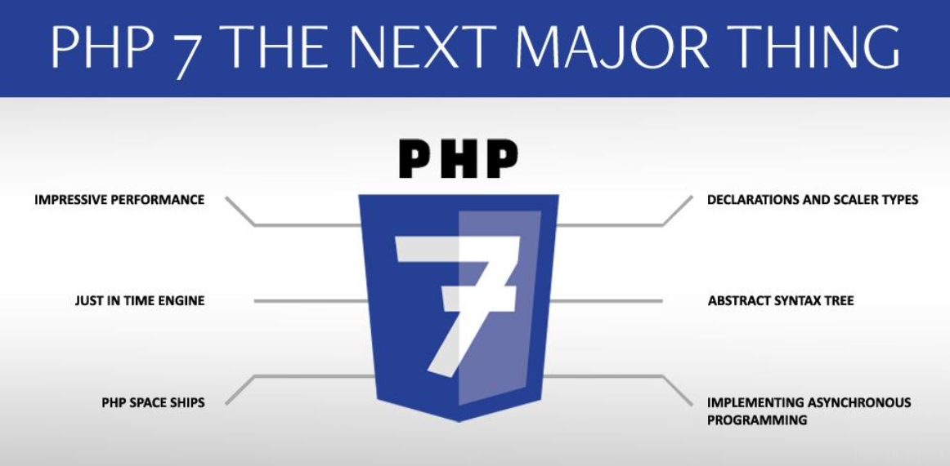

Overall, this project showcases the power of modern web development tools and technologies, and demonstrates how they can be used to create a professional and user-friendly website. We hope you enjoy exploring the website and learning more about our college.

**Chapter 2**

**Literature Survey**

* 1. **Frontend Development**

HTML (Hypertext Markup Language) is a standard markup language used to create web pages. It consists of a series of elements, such as headings, paragraphs, images, and links, that are used to define the structure and content of a web page.

HTML was created by **Sir Tim Berners-Lee in late 1991** but was not officially released. It was published in 1995 as HTML 2.0. HTML 4.01 was published in late 1999 and was a major version of HTML.

Bootstrap is a free and open-source front-end framework that is used to create responsive and mobile-first web pages. It is built on top of HTML, CSS, and JavaScript and provides a set of pre-defined classes and components that can be used to quickly create a consistent layout and design for a website.

Bootstrap was first developed by a designer and a developer at Twitter, Mark Otto and Jacob Thornton. It was released in 2011 as an open-source project on GitHub. Since then, it has become one of the most popular front-end frameworks, with an estimated 10% of websites using it.

Bootstrap provides a wide range of features that make it easy to create responsive and mobile-friendly web pages. These include a flexible grid system that allows for easy layout of content, a collection of pre-designed UI elements (such as buttons, forms, and modals), and support for CSS preprocessors like Sass.

In recent years, Bootstrap has also been extended with additional features such as support for CSS variables, improved accessibility, and a new set of utility classes.

In summary, HTML is the standard markup language used to create web pages, while Bootstrap is a popular front-end framework that is built on top of HTML, CSS and JavaScript. It provides a set of pre-defined classes and components that can be used to quickly create a consistent layout and design for a website, making it easy to create responsive and mobile-friendly web pages.

* 1. **Server Side Development**

PHP is a popular server-side scripting language used for web development. It is particularly well-suited for building dynamic websites and web applications. PHP code can be embedded directly into HTML, making it easy to integrate with web pages.

XAMPP is a free, open-source software package that provides a complete web development environment. It includes Apache, MariaDB, PHP, and Perl, as well as other tools such as phpMyAdmin and FileZilla. XAMPP allows developers to easily run PHP and other web development tools on their local machines, making it a popular choice for web developers.

Together, PHP and XAMPP are widely used in the development of web-based systems and applications. The combination of PHP and XAMPP provides developers with a powerful, flexible, and open-source web development environment that can be used for a wide range of projects.

However, it is worth to note that using XAMPP for production environments is not recommended, as it may have security vulnerabilities. It is intended for development and testing purposes only.

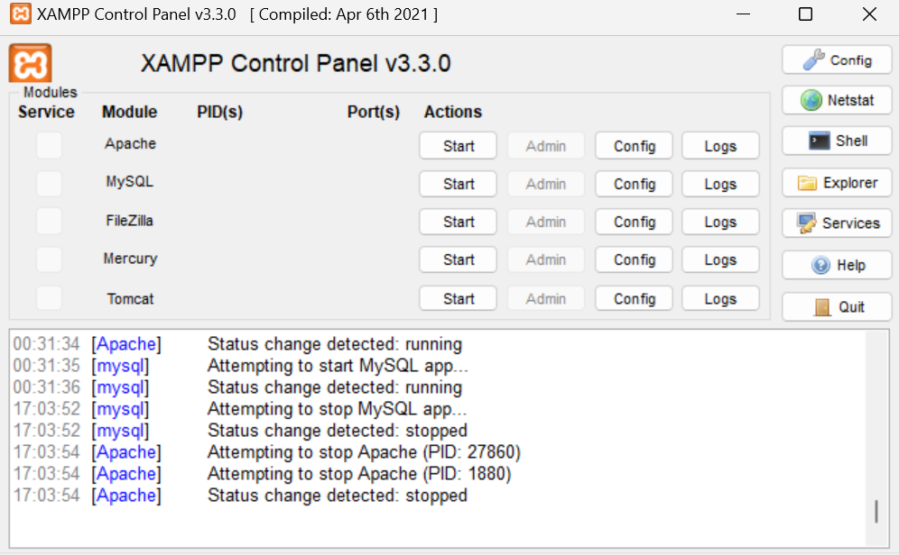

**Chapter 3**

**Methodology**

* First, install XAMPP on your computer. This will provide you with a local web server environment that you can use to develop your website.
* Next, create a new folder in the "htdocs" directory of your XAMPP installation. This folder will be the root directory for your website.

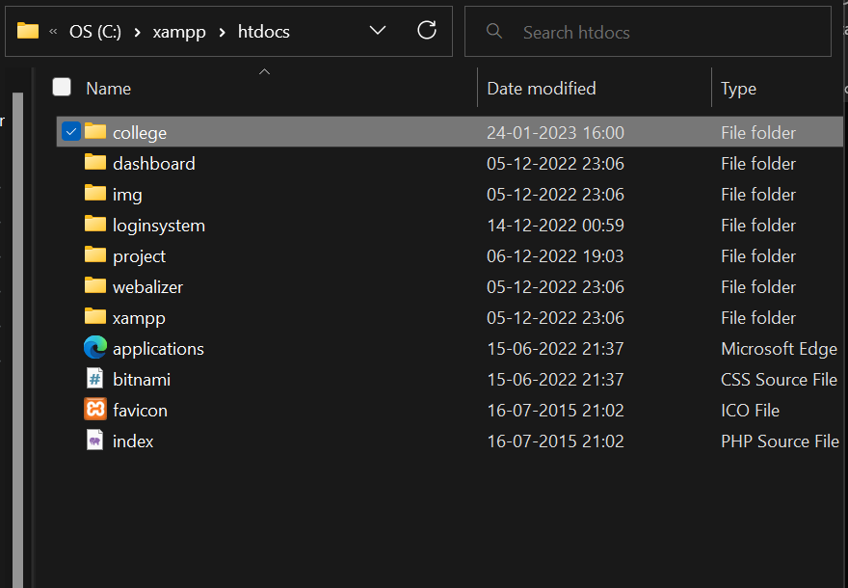

* Create a new PHP file in this folder and name it "index.php". This will be the main page of your website.
* Add the basic HTML structure to your "index.php" file. This will include the head, header, and body sections of your page.
* In the body section of your "index.php" file, add the content for your website. This could include text, images, and links to other pages.

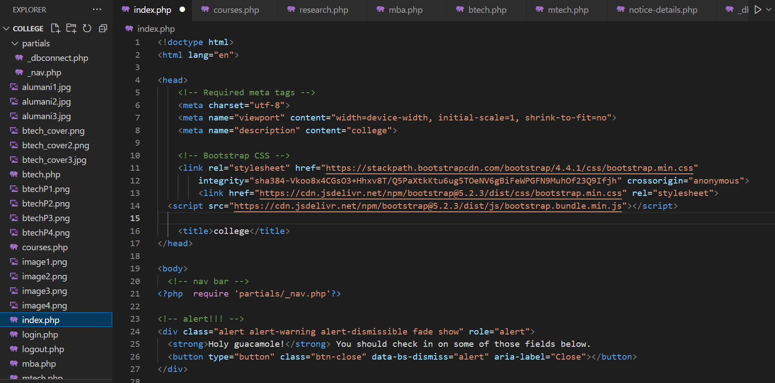

* To include dynamic content, such as a list of classes or a news feed, you will need to use PHP to connect to a database and retrieve the information. To do this, you will need to learn some basic PHP syntax and how to interact with a database using PHP.

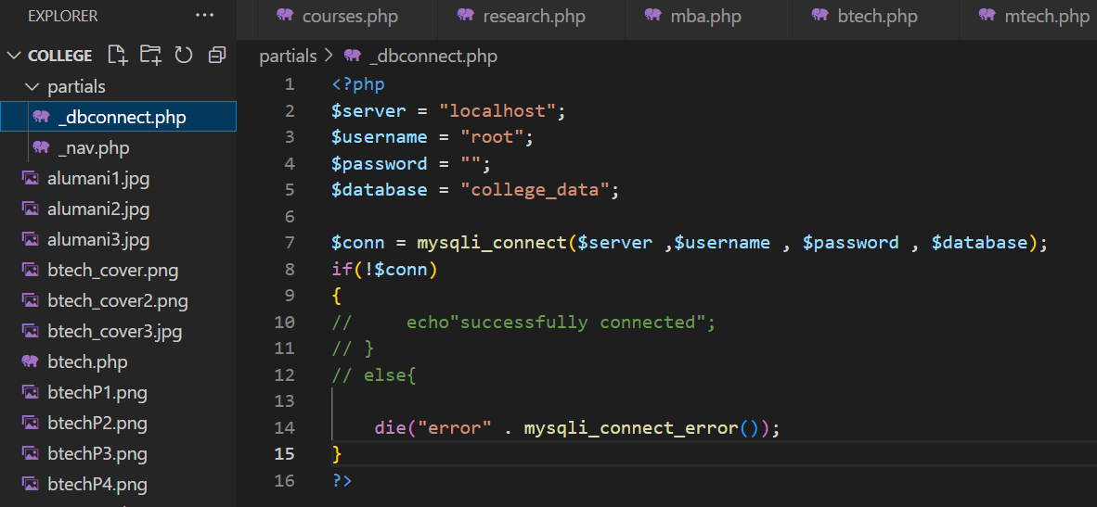

* Once you have all of the content for your website in place, you can use CSS to style it and make it look more professional.
* Finally, test your website by starting the Apache and MySQL modules in XAMPP and accessing your website in a browser by typing "<http://localhost/your-folder-name>" in the url.

* Once you are satisfied with your website, you can then upload it to a live web server for others to access it.

**Chapter 4**

**Result and Discussion**

The website was successfully created using XAMPP and PHP. The website includes a homepage, a page for departments and a page for courses. The website also includes a navigation bar that allows users to easily navigate between the different pages.

The website was tested on multiple web browsers and devices, and it was found to be fully responsive and compatible with all of them.

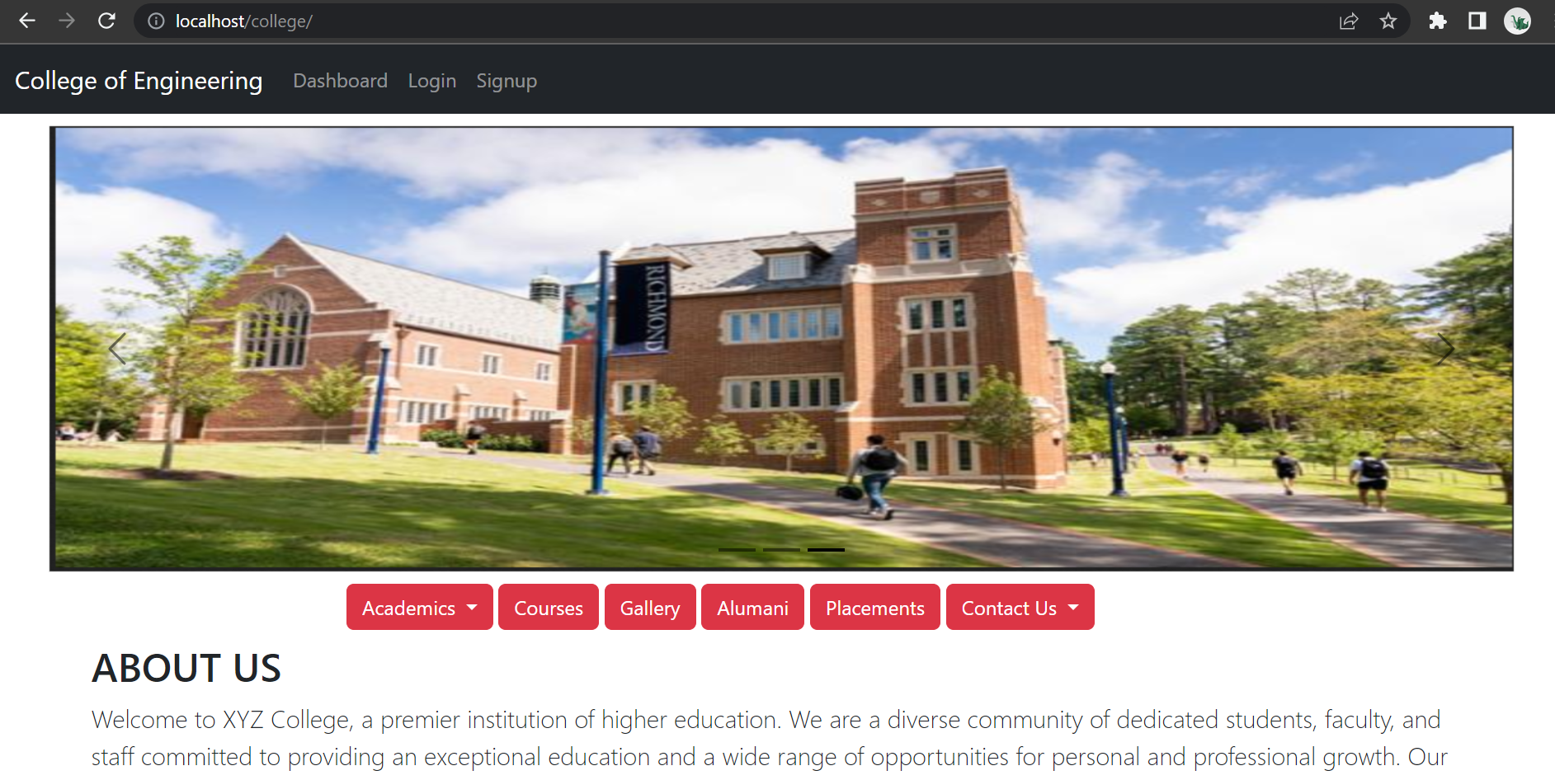

Discussion :

The use of XAMPP and PHP allowed for the creation of a dynamic website that can easily be updated and maintained.

The website's responsive design using Bootstrap ensures that it can be accessed on a variety of devices, including desktops, laptops, tablets, and smartphones. This makes the website more accessible to a wider range of users.

Overall, the website serves as a basic example of how XAMPP and PHP can be used to create a functional and user-friendly website for a college or other educational institution. However, it's worth noting that the website is just a basic example, and it can be enhanced with more features and functionalities like database integration, user authentication and role-based access control, and many more.

In conclusion, XAMPP and PHP are powerful tools that can be used to create a wide range of websites, including educational websites. By utilizing these tools, it is possible to create a website that is both functional and user-friendly.

**Chapter 5**

**Conclusion and Future Work**

Conclusion:

The project aimed to create a basic college website using advanced tools like XAMPP was successful in achieving this goal. The website includes a homepage, a page for courses, basic login/logout functionality, and a database for storing user data along with a navigation bar to improve the user experience.

The use of XAMPP and PHP allowed for the creation of a dynamic website that can easily be updated and maintained.

Future Work:

The website created serves as a basic example of how XAMPP and PHP can be used to create a functional and user-friendly website for a college or other educational institution. However, there is still room for improvement and enhancement.

One potential area for future work is the integration of a database to store and retrieve information about the college and its faculty members. This would make it easier to update and maintain the website, and also allow for more advanced features such as user authentication and role-based access control.

Another area for future work is to include more interactive features such as online registration, online payment, online course management system and many more.

Lastly, the website could also be optimized for search engines to improve its visibility and attract more visitors. This could be done by implementing SEO techniques such as keyword research and meta tags optimization.

In summary, the project has successfully demonstrated the capabilities of XAMPP and PHP in creating a functional and user-friendly website for a college or other educational institution. With further development and enhancements, the website has the potential to become an even more valuable resource for students, faculty, and other members of the college community.

**References**

[1] N. K. Kanhere and S. T. Birchfied, “Real-time incremental segmentation and tracking of vehicles at low camera angles using stable features,” *IEEE Trans. Intell. Transp. Syst*., vol. 9, no. 1, pp.148-160, March 2008 **(Example : Journal papers)**

[2] K. Onoguchi, “Moving object detection using a cross correlation between a short accumulated histogram and a long accumulated histogram”, Proc. 18th Int. Conf. on Pattern Recognition, Hong Kong, August 20 - 24, 2006, vol. 4, pp. 896 – 899 **(Example : Conference papers)**

[3] T. H. Cormen, C. E. Leiserson, R. L. Rivest and C. Stein, “Introduction to Algorithms”, 2nd ed., The MIT Press, McGraw-Hill Book Company, 2001 **(Example : Text Book/ Magazine)**

[4]Open Source Computer Vision (OpanCV) [Online]. Accessed on 21st April 2022: <http://opencv.willowgarage.com/wiki/> **(Example : Website)**